QTP
CHECKPOINTS



Guided By: Submitted By:
Utpal Sardar Yogesh Tiwari
Krishna Goswami

Table of contents-
1. What Is Checkpoints.
2. Checkpoint Description.
3. Ways to Create Checkpoint.
5. Example.

What Is Checkpoints
“A Checkpoint is a step in your test that compares a specified Item during a run session with the values stored for the same item with in the test.This enables you to identify whether or not your application is functioning correctly.”

Checkpoint Description
Checkpoint enables user to identify whether AUT is correctly working or not by comparing current value of a particular property with expected value of that property.
There are seven types of checkpoints in QTP 11 version:
1.Standard Checkpoint: Check Property value of an object in your application. For Example- A Radiobutton is activated after it is selected or you can check the value of an Edit box.
2.Bitmap Checkpoint: Checks an area of your application as a bitmap. For example- Suppose we have a website that can display a map of a city the user specifies.The map has control keys for zooming,then we can check that the maps zooms correctly.
3.Text Checkpoint: Check that the text string is displayed in the appropriate place in an application.For example- Suppose a webpage displays the sentence Flight departing from New York to San Francisco ,Then you can create a text checkpoint that checks the words “New York” is displayed between “Flight departing from” and “to San Francisco”.
4.Text Area Checkpoint: Check that a string is displayed within a defined area in a Windows-based application,according to specified criteria.For example- Suppose your VB application has a button that says View Doc<Num>,where <Num> is replaced by the four digit code entered in a form elsewhere in the application.You can create a text area checkpoint to confirm that the number displayed on the button is same as the number entered in the from.
5.Accessibility Checkpoint: Identifies areas of your Web site that may not conform to the World Wide Web Consortium (W3C) Web Content Accessibility Guidelines.For example- W3C Web Content Accessibility Guidelines requires you to provide a text equivalent for every non-text element. You can add an Alt property check to check whether objects that require the Alt property under this guideline, do in fact have this tag.
6.Database Checkpoint: Checks the contents of a database accessed by your application.For example- you can use a database checkpoint to check the contents of a database containing flight information for your Web site.
7.XML Checkpoint: Checks the data content of XML documents in XML files or XML documents in Web pages and frames.

Ways To Create Checkpoints
There are 4 ways to create Checkpoint in QTP.
1.We can create a checkpoint at the recording time of application.
Goto Insert MenuàCheckpointsàThen Select the type of Checkpoint.
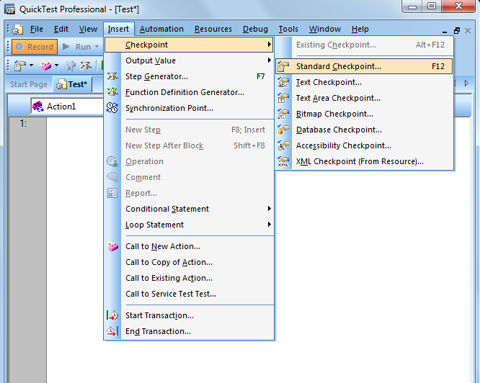

1. We can create Checkpoint by Expert view.
We have to put here manualy by code-
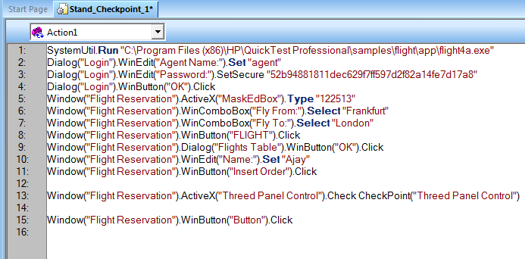
3. We can create Checkpoint by Keyword View.Goto Keyword view Select ObjectàClick Value Coloumn of object 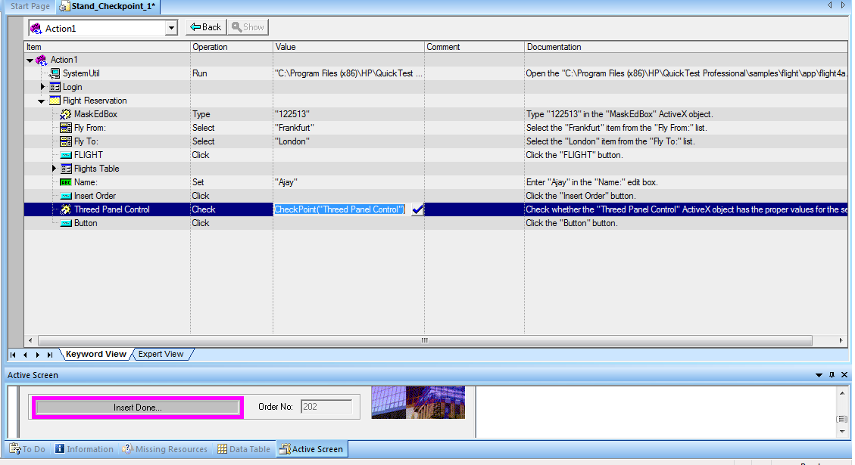
4. We can create Checkpoint by Active Screen Also.
Right click on object.
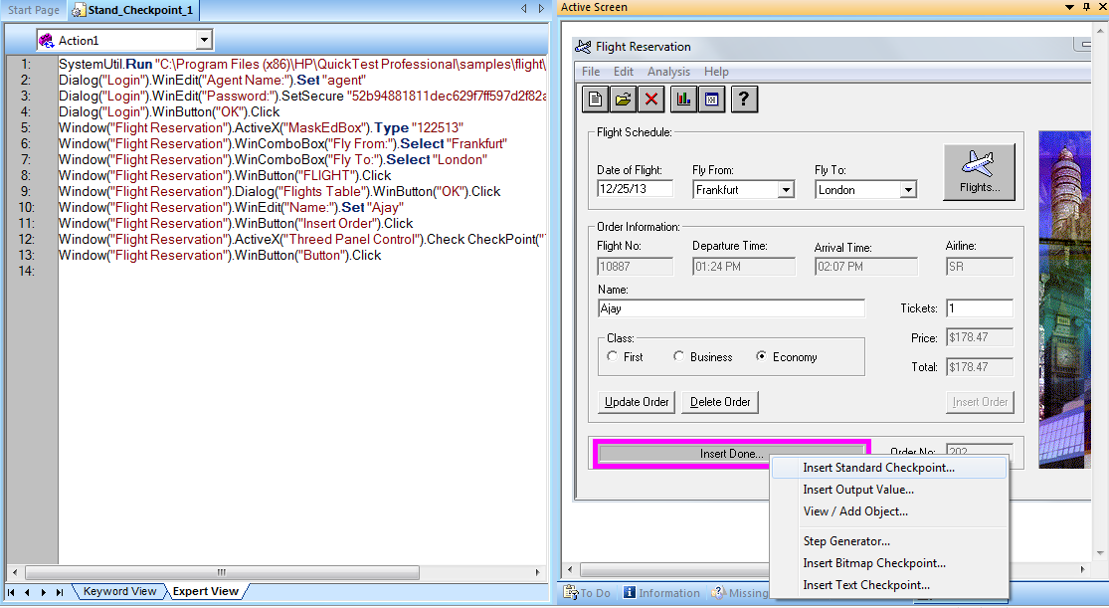

Example
Create a Checkpoint on order no
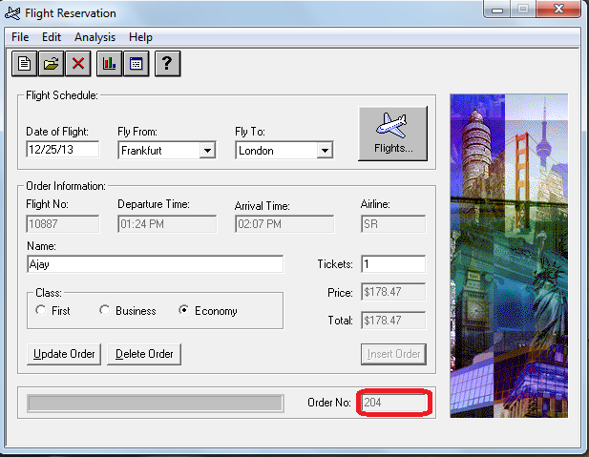

- Goto INSERTàCHECKPOINTàSTANDARD CHECKPOINT.
- In Active Screen Right Click On Order No Field and Select
STANDARD CHECKPOINT PROPERTIES Dialog Box Apears-
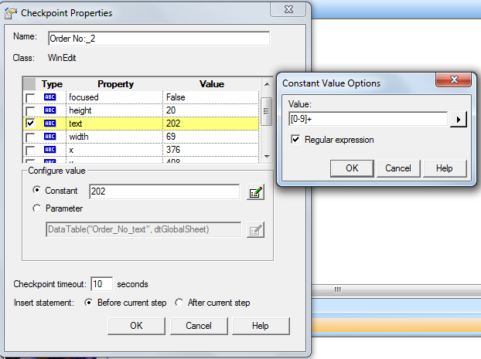
- We can also open Checkpoint Properties Dialog Box By Keyword View-
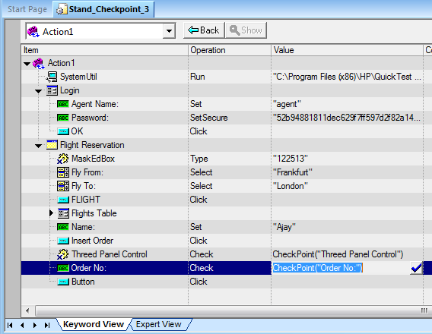
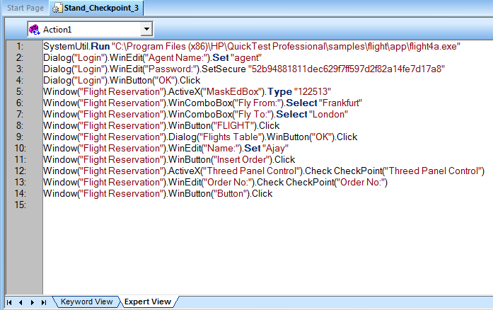
- After Run The Script We can Observe the Test Results.
